**VISVESVARAYA TECHNOLOGICAL UNIVERSITY**

**"Gnana Sangama", Belgaum 560002, Karnataka**



**Department of Computer Science & Engineering**

**A DBMS Mini Project Report on**

**“TYRE SALES MANAGEMENT SYSTEM”**

**In partial fulfilment of DBMS Laboratory**

**In Computer Science and Engineering for the Academic Year 2018**

**Submitted by:**

**VINAY V**

**(1SK16CS042)**

**Under the guidance of**

**MR. Naveen. T. H, M.Tech**

**Assistant professor**

**Department of CSE**

**GOVT. S.K.S.J TECHNOLOGICAL INSTITUTE**

**(Affiliated to Visvesvaraya Technological University, Belgaum)**

**KR circle, Bangalore – 560001**

**DEPARTMENT OF COMPUTER SCIENCE & ENGINEERING**



**CERTIFICATE:**

This is to certify that Mr.VINAY V(1SK15CS042) of 5th Semester have successfully completed the mini project “TYRE SALES MANAGEMENT SYSTEM**”** in Database Management System and Database Management System Laboratory as prescribed by the VISVESVARAYA TECHNOLOGICAL UNIVERSITY for the academic year 2018-2019.

Signature of the Guide Signature of the HOD

Mr. Naveen T. H, M.Tech Dr.T. G.Basavaraju , M.Tech.,Ph.D

Asst. professor, Dept of CSE Prof.& HOD of CSE

**Name of the examiners** **Signature with date**

1

2

**ABSTRACT**

This is an integrated service which provides all information about the airport, flights and its routes, employee details for public. The proposed system is a web based application which provides information regarding timings, routes, fair.

This system manages public feedback about services through its complaint management system. This system also contains information about the various departments and employee who working in the departments.

The study for the establishment of a complete flight information system that provide airport management authorities as passengers abroad the aircraft before departure and after the arrival of the various kinds of information, in order to get instant information, flight management system has been capture by the aeronautical information services system and real time rendering, to filter out the relevant flight information, and then import the system database, providing immediate treatment after working platform to operate.

**ACKNOWLEDGEMENT**

I express my sincere gratitude to **Dr. K G CHANDRASHEKAR** the principal Govt. SKSJTI for his valuable guidance, suggestion and consistent encouragement during the course of my mini project work and timely assistance for completion of the project.

I thank to entire faculty of the Computer Science and Engineering Department, especially **Dr.T.G BASAVARAJU**, Head of the Department CSE, who has given me confidence to believe in myself and complete the project.

I’m grateful to **Prof. NAVEEN T.H,** my internal guide, Computer Science and Engineering Department, for his valuable guidance, suggestion and consistent encouragement during the course of my mini project

Last but not least I would also like to thank my parents and friends for their moral support.

**Vinay V**

**CONTENTS**

*Chapters*

1. **INTRODUCTION**
   1. Objectives
   2. Over view

1.2.1 Admin module

* + 1. Brans module
    2. Tyre sales module

1.2.4 Sales details module

**2. SYSTEM ANALYSIS**

2.1 Existing system

2.2 Proposed system

2.3 System requirement specification

2.3.1 General description

2.3.2 System objectives

2.3.3 System requirements

2.3.3.1 Non Functional requirement

2.3.3.2 Functional requirement

2.3.4 Software and hardware requirements

**3. SYSTEM DESIGN AND IMPLEMENTATION**

3.1 Input and output design

3.2 Database

3.3 System tools

3.3.1 Front end

3.3.2 Back end

3.4 Tables

* 1. E-R Diagrams
  2. Data flow diagram(DFD)
  3. Testing and Validation

**4.CONCLUSION**

4.1REFERENCES

4.2APPENDIX

**Chapter- 1**

**INTRODUCTION**

This is an integrated service which provide all information about the tyres, offers and its prices for customers. The proposed system is a stand-alone application which provides information regarding brands, sixes, price.

This system manages public feedback about services through its complaint management system. The proposed system uses Server SQl, visual c# and Visual Studio for the development of this management system.

Server SQl is an open-source relational database management system(RDBMS)being used by many small and big business. Server SQl is database system that is used on the web and runs on the server, Server SQl is fast, reliable, and easy to use and it uses standard sql.

The data in a Server SQl database are stored in tables. A table is collection of related data, and consists of columns and rows. Visual c# is combined with Server SQl are cross-platform. A query a database for specific information and have a record set returned.

C# (pronounced "C-sharp") is an [object-oriented programming](https://searchmicroservices.techtarget.com/definition/object-oriented-programming-OOP) language from Microsoft that aims to combine the computing power of [C++](https://searchsqlserver.techtarget.com/definition/C) with the programming ease of [Visual Basic](https://searchwindevelopment.techtarget.com/definition/Visual-Basic). C# is based on C++ and contains features similar to those of [Java](https://www.theserverside.com/definition/Java).

C# is designed to work with Microsoft's [.Net](https://searchwindevelopment.techtarget.com/definition/NET)platform. Microsoft's aim is to facilitate the exchange of information and services over the Web, and to enable developers to build highly[portable](https://searchstorage.techtarget.com/definition/portability) applications. C# simplifies programming through its use of Extensible Markup Language ([XML](https://searchmicroservices.techtarget.com/definition/XML-Extensible-Markup-Language)) and Simple Object Access Protocol ([SOAP](https://searchmicroservices.techtarget.com/definition/SOAP-Simple-Object-Access-Protocol)) which allow access to a programming[object](https://searchmicroservices.techtarget.com/definition/object) or [method](https://whatis.techtarget.com/definition/method) without requiring the programmer to write additional code for each step. Because programmers can build on existing code, rather than repeatedly duplicating it, C# is expected to make it faster and less expensive to get new products and services to market.

**OBJECTIVE**

The objectives of the project are as follows:

* Users can easily get into application.
* Users can view the details of various tyres and even the details of the tyres which are on sales of various brands.
* Users can view tyre details and and offer price.
* User can buy tyres by mention some details.
* Admin can see sales details.

**1.2 OVERVIEW**

Tyre Sales Management System consists of the following implementation modules.

TyreSales management system

Buy Tyre

See Sales Details

This module contains various facilities like buy tyres which customer and Admin will see the details.

Brands

View various tyre details

Various given by respective tyres

This module contains facilities like brands details and tyres details which are on sales.

Purchase management system

View the prices for your quantities.

This module contains facilities to view the prices for your quantities of tyres.

Sales management system

View the customer name,mobile no,tyre details,quantities,total cost,payment mode

This module contains various details like customer name,mobile no,tyre details,quantities,total cost,payment mode.

**Chapter-2**

**2.3 SYSTEM REQUIREMENT SPECIFICATION**

2.3.1 GENERAL DESCRIPTION

Product Description:

Tyre Sale management system is an stand-alone system which helps the user to know the details of the tyres, prices and their offers, it also have a transaction management system in which admin can see their sales.

By visiting the application the users can get tyre details. Other than knowing the tyre details, the users can get all sorts of information about tyre offers.

Problem Statement:

The problem occurred before having stand-alone system includes:

* File lost

When online system is not implemented the complaints are reported in files. The files are always lost due to some human errors.

* Time consuming

When there is no computerized system there was need to maintain each record of tyre details their sale or offer, if any information user wants to know about their tyre it will be available only at the respective brands so this causes more time consuming.

* Most updates are unnoticeable

When stand-alone systems is not implemented any changes in price, offers etc when updated, the details of these things are only available at the shop.

2.3.2 SYSTEM OBJECTIVES

* Improvement in Control and performance

The system is developed to cope up with current issues and problems of the shop. The system helps to customer name, mobile no, tyre details, quantities, total cost ,payment mode.

.

* Save time

User can see details of customer name, mobile no, tyre details, quantities, total cost ,payment mode.

* Easy to Use

A person with just application and a pc can do things such as buy, transaction, and fetch

the details.

2.3.3 **SYSTEM** **REQUIREMENTS**

2.3.3.1 NON FUNCTIONAL REQUIREMENTS

* EFFICIENCY REQUIREMENT

When a Tyre sale Management System will be implemented then the user can maintain customer name, mobile no, tyre details, quantities, total cost ,payment mode. information fast & easily.

* RELIABILITY REQUIREMENT

The system should accurately perform maintenance, store complaints, and show the details of tyre such as price, offers.

* USABILITY REQUIREMENT

The system is designed for a user friendly environment so that user and admin of tyre can perform various tasks easily and in an effective way.

* IMPLEMENTATION REQUIREMENTS

In implementing whole system it uses visual c# for both front end and middle end. Which will be used for database connectivity and the backend i.e. the database part is developed using Server SQL.

* DELIVERY REQUIREMENTS

The whole system is expected to be delivered in six months of time with a weekly evaluation by the project guide.

2.3.3.2 FUNCTIONAL REQUIREMENTS.

**BRANDS AND TYRES**

Description of Feature

This feature allows the users to view the brands and tyres. Users are required to enter the quantity, when they enter the data then the system will display price details.

Functional Requirements

* System must allow the users to enter the source and destination stations.
* System must be able to retrieve information from the database.

**TYRES DETAILS**

Description of feature

This feature allows the users to view tyre, tyre details, quantities, total cost ,payment mode., when they enter the data then the system will show the Transaction table.

Functional Requirements

* System must allow the users to enter their details.
* System must be able to process information from database.

2.3.4 SOFTWARE AND HARDWARE REQUIREMENTS

This section describes the software and hardware requirements of the system.

SOFTWARE REQUIREMENTS:

* Operating system- Windows 7 or 8.1 is used as the operating system as it is stable and supports more features and is more user friendly.
* Database Server-SQL is used as database as it easy to maintain and retrieve records by simple queries which are in English language which are easy to understand and easy to write.
* Development tools and Programming language visual c# to do front end and back end to connect to database.
* HARDWARE REQUIREMENTS:
* Intel core i3 6th generation is used as a processor because it is fast than other processors and provide reliable and stable and we can run our pc for long time. By using this processor we can keep on developing our project without any worries.
* Ram 8GB is used as it will provide fast reading and writing capabilities and will in turn support in processing

**Chapter-3**

**SYSTEM DESIGN AND IMPLEMENTATION**

System design is the solution for the creation of a new system. This phase focuses on the detailed implementation of the feasible system. It emphasis on translating design. Specifications to performance specification. System design has two phases of development

* Logical design
* Physical design

During logical design phase the analyst describes inputs (sources), outputs (destinations), databases (data sores) and procedures (data flows) all in a format that meets the user requirements. The analyst also specifies the needs of the user at a level that virtually determines the information flow in and out of the system and the data resources. Here the logical design is done through data flow diagrams and database design. The physical design is followed by physical design or coding. Physical design produces the working system by defining the design specifications, which specify exactly what the candidate system must do. The programmers write the necessary programs that accept input from the user, perform necessary processing on accepted data and produce the required report on a hard copy or display it on the screen.

**3.1 INPUT AND OUTPUT DESIGN**

3.1.1 INPUT DESIGN:

Input design is the link that ties the information system into the world of its

Users. The input design involves determining the inputs, validating the data, minimizing the data entry and provides a multi-user facility. Inaccurate inputs are the most common cause of errors in data processing. Errors entered by the data entry operators can be controlled by input design. The user-originated inputs are converted to a computer based format in the input design. Input data are collected and organized into groups of similar data. Once identified, the appropriate input media are selected for processing. All the input data are validated and if any data violates any conditions, the user is warned by a message. If the data satisfies all the conditions, it is transferred to the appropriate tables in the database. In this project the user details are to be entered at the time of registration. A page is designed for this purpose which is user friendly and easy to use. The design is done such that users get appropriate messages when exceptions occur.

3.1.2 OUTPUT DESIGN:

Computer output is the most important and direct source of information to the user. Output design is a very important phase since the output needs to be in an efficient manner. Efficient and intelligible output design improves the system relationship with the user and helps in decision making. Allowing the user to view the sample screen is important because the user is the ultimate judge of the quality of output. The output module of this system is the selected notifications.

**3.2 DATABASE**

DATABASE DESIGN:

Databases are the storehouses of data used in the software systems. The data is stored in tables inside the database. Several tables are created for the manipulation of the data for the system. Two essential settings for a database are

* Primary Key-the field that is unique for all the record occurrences.
* Foreign Key-the field used to set relation between tables.

Normalization is a technique to avoid redundancy in the tables.

**3.3 SYSTEM TOOLS**

The various system tools that have been used in developing both the front end and the back end of the project are being discussed in this chapter.

3.3.1 FRONT END:

Visual C#

C# (pronounced "C-sharp") is an [object-oriented programming](https://searchmicroservices.techtarget.com/definition/object-oriented-programming-OOP) language from Microsoft that aims to combine the computing power of [C++](https://searchsqlserver.techtarget.com/definition/C) with the programming ease of [Visual Basic](https://searchwindevelopment.techtarget.com/definition/Visual-Basic). C# is based on C++ and contains features similar to those of [Java](https://www.theserverside.com/definition/Java).

3.3.2 BACK END:

The back end is implemented using Server-SQL which is used to design the databases.

SERVER-SQL

Server-SQL is the world's second most widely used open-source relational database management system (RDBMS). The SQL phrase stands for Structured Query Language.

By using this software the design of tables will be created.

**3.4 TABLES**

* System Table

|  |  |
| --- | --- |
| Name | Datatype |
| Property | varchar(20) |
| Values | varchar(10) |

* Brands Table

|  |  |
| --- | --- |
| Name | Datatype |
| Bid | varchar(50) |
| BrandName | Varchar(50) |

* TyreInfo

|  |  |
| --- | --- |
| Name | Datatype |
| Tname | Varchar(50) |
| Tcost | int |
| Tsize | Varchar(50) |
| Bid | Varchar(50) |
| Tid | int |

* TyreOffer details

|  |  |
| --- | --- |
| Name | Datatype |
| Warranty | int |
| Discount | int |
| Ofid | Varchar(50) |
| Type | Varchar(50) |
| Tid | int |

* Payment

|  |  |
| --- | --- |
| Name | Datatype |
| Pid | int |
| Pname | Varchar(50) |

* Transaction details

|  |  |
| --- | --- |
| Name | Datatype |
| Tnum | Int |
| Cname | Varchar(50) |
| Cmob | nvarchar(10) |
| Tid | Int |
| Quantity | nvarchar(50) |
| Pid | int |
| Total | Nvarchar(50) |

**3.5 E-R DIAGRAM**

brand

bid

Brandname­­­

has

Tyre_info

tid

tcost

tsize

tname

has

warranty

discount

buy

payments

pid

pname

Stored in

Transcation

tnum

total

cmob

quantity

cname

has

Tyre_offer

ofid

type

have

**3.6 DATA FLOW DIAGRAMS**

A Data Flow Diagram (DFD) is a structured analysis and design tool that can be used for flowcharting. A DFD is a network that describes the flow of data and the processes that change or transform the data throughout a system. This network is constructed by using a set of symbols that do not imply any physical implementation. It has the purpose of clarifying system requirements and identifying major transformations. So it is the starting point of the design phase that functionally decomposes the requirements specifications down to the lowest level of detail. DFD can be considered to an abstraction of the logic of an information-oriented or a process-oriented system flowchart. For these reasons DFD’s are often referred to as logical data flow diagrams.

EXTERNAL ENTITY

An external entity is a source or destination of a data flow. Only those entities which originate or receive data are represented on a data flow diagram. The symbol used is a rectangular box.

PROCESS

A process shows a transformation or manipulation of data flow within the system. The symbol used is an oval shape.

DATAFLOW

The data flow shows the flow of information from a source to its destination. Data flow is represented by a line, with arrowheads showing the direction of flow. Information always flows to or from a process and may be written, verbal or electronic. Each data flow may be referenced by the processes or data stores at its head and tail, or by a description of its contents.

DATASTORE

A data store is a holding place for information within the system: It is represented by an open ended narrow rectangle. Data stores may be long-term files such as sales ledgers, or may be short-term accumulations: forexample batches of documents that are waiting to be processed. Each data store should be given a reference followed by an arbitrary number.

* DATA FLOW DIAGRAM FOR SALE DETAILS

Admin

sale module

* DATA FLOW DIAGRAM FOR PURCHASE

User

price

Price and offer module

* DATA FLOW DIAGRAM FOR TRANSACTION

User

Tyre price table

Transaction module

**TESTING AND VALIDATIONS**

HOME**:**

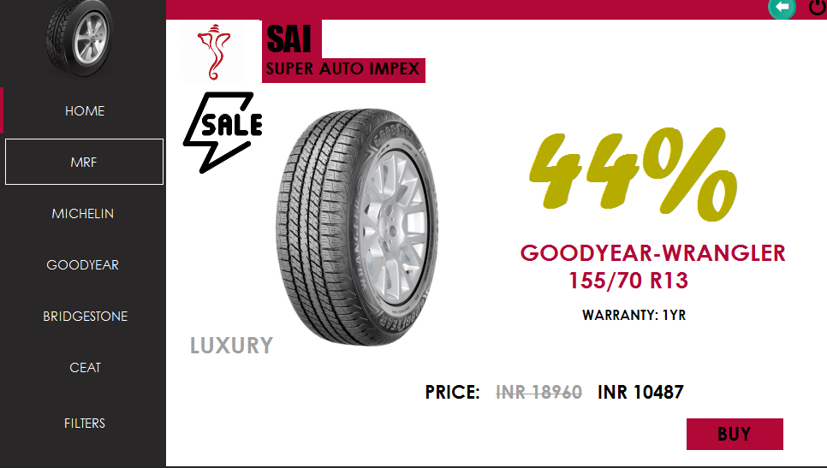

SALE DETAILS:

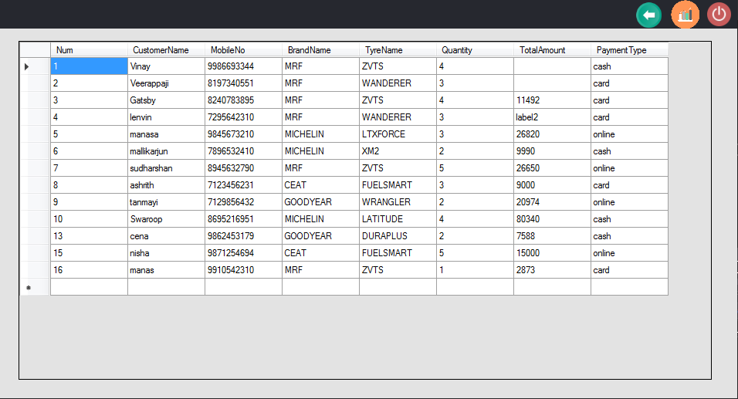

PURCHASING MODULE:

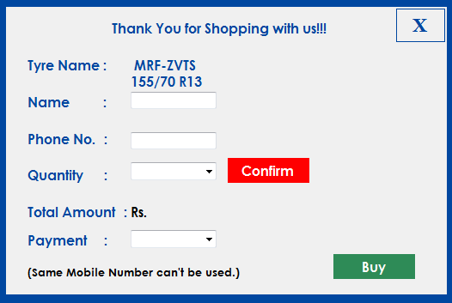

ADMIN MODULE:

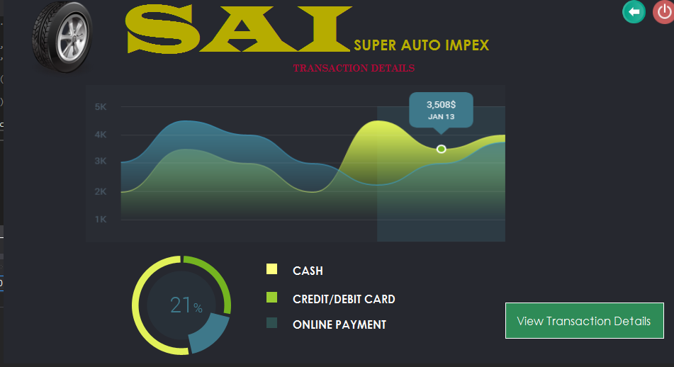

**Chapter-4**

**CONCLUSION**

The project entitled Tyre Sale Management System was completed successfully. The system has been developed with much care and free of errors and at the same time it is efficient and less time consuming. The purpose of this project was to develop a stand-alone application.

This project helped us in gaining valuable information and practical knowledge on several topics like designing application in visual studio, usage of responsive templates, designing of android applications, and management of database using Server-SQL. The entire system is secured. Also the project helped us understanding about the development phases of a project and software development life cycle. We learned how to test different features of a project.

This project has given us great satisfaction in having designed an application which can be implemented to any shop to manage their tyre, sales and even various brands by simple modifications.

There is a scope for further development in our project to a great extend. A number of features can be added to the system in future like to check whether the stock is there, managing each tyre details, adding tyres and to show the trigger generated to the User Interface(UI). So this are the features may be included in the feature for the further development of the project.

**REFERENCES**

[1] Jon Skeet. “C# in Depth”,3rd Edition

[2] Benjamin Nevarez. “High Performance”.

[3]Eldhose PA(YouTube Channel)

[4]SaLaaR HuSceyN.”C# UI Academy”.

**APPENDIX:**

**SAMPLE CODE -**

* CODE TO CREATE STORED PROCEDURE

CREATE PROCEDURE [dbo].transact_sp

@cname varchar(50),

@cmob nvarchar(50),

@tid int,

@quantity nvarchar(50),

@pid int,

@total nvarchar(50)

AS

insert into Transactions(cname,cmob,tid,quantity,pid,total) values(@cname,@cmob,@tid,@quantity,@pid,@total)

RETURN 0